ECE 682 or 683

Winter 2006

DARPA Urban Challenge related Design Project

In 2004 and 2005 DARPA set a challenge for developing autonomous ground vehicles that would traverse an off-road course between Los Angeles and Las Vegas (225 to 250 miles) in the fastest time and in less than 10 hours. A team from OSU came in 6th best among 116 applicants and 10th in 2005. DARPA is changing the event to be an “Urban Challenge” in November 2007 and offering a $2 million prize. The Urban Challenge will be held on city streets with vehicles solving typical problems of real traffic.

In Winter 2005 we ran a Design Project that emulated some aspects of the 2005 Grand Challenge. This year’s class is to develop a robotic vehicle that solves some of the problems of the 2007 Urban Challenge. The vehicle will be tested on a similar but simplified and much shorter course. With enough student participation, two separate teams will be formed to compete against each other. Good ideas, developments and designs will be used in the 2007 OSU vehicle.

Each Team will have 2 sub-groups Sensors and (High Level) Control. (The robot will have low level control ready. GPS emulation will be supplied by the camera system in the lab.) The testing and race area will be in the lab. The general development schedule is below. Presentation dates will be inserted. A report is expected.

Week 1: Finalizing preliminary design.
Week 2-3: Sensors—Interfacing LIDAR, ultrasonics and emulated GPS
Control—Testing of lsimple control on simulator
Week 4: System integration design and decisions
Week 5-6: Sensors—Sensor fusion software and testing
Control—Control software and testing
Week 7-8: System integration
Week 9: Testing
Week 10: Race

Students can also participate outside the sub-groups by developing individual mini-projects that can be integrated and tested within the above schedule. Notes on these are listed below:
- You can evaluate the basic (SICK) LIDAR unit. See if it is worthwhile to have two on top of each other. Pointing a little different. Check price, models. Is there anything comparable in the market. How would you use this? In fact, can you think of any other configuration of LIDAR placements? (Last year, there were people rotating one with a motor, pointing one slightly downwards from the tip of a pole, etc.)
- You can evaluate ultrasonic sensors in different situations. Can they be used for detecting passing cars?
- Can we design an active suspension system that we can use for the sensor package? (CMU has such a system. See their post- race evaluation report.) Specs, hardware, design? Which sensors may need more than passive damping?
- How about the control system for rotating a dish antenna? Both this and the above need a microprocessor system.
- Test the camera system for lane detection.

Each sub-group from the two possible teams will be coached by a different graduate student.

The robots will be available in the lab for tests and short runs,

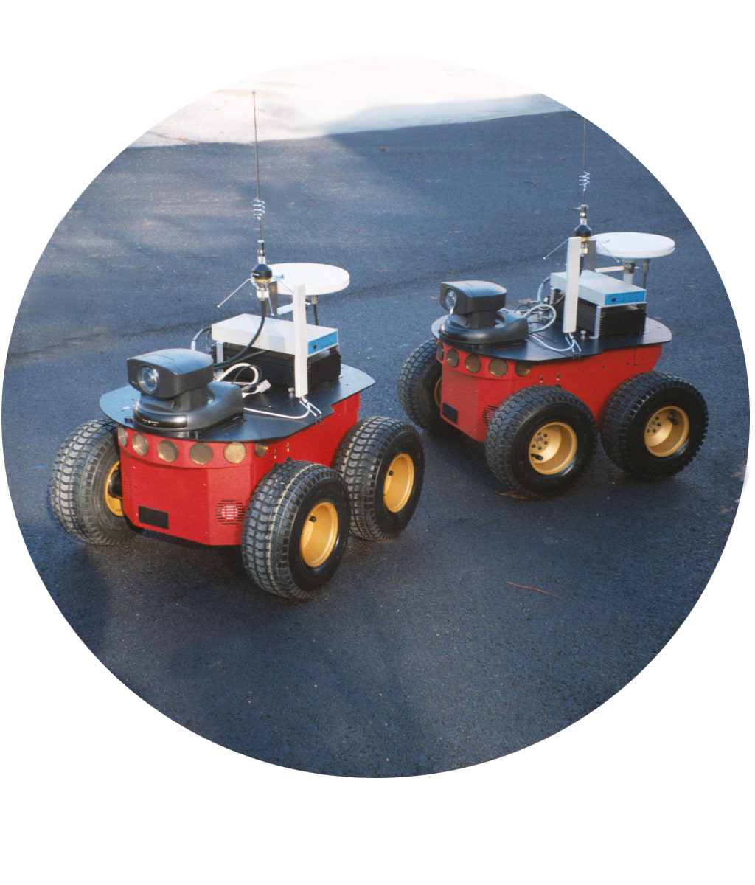

Instructor: U. Ozguner

